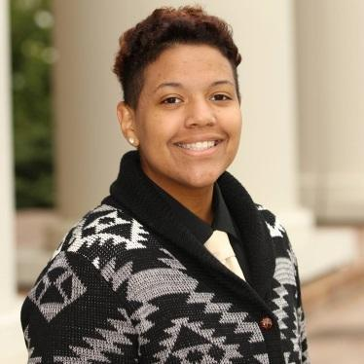
Tamara J. Morris-Thompson
Born: England, UK| (770) 776-9592 | tamara@morrthom.com|Residence: Buford, GA
PROFESSIONAL EXPERIENCE
The Santa Fe Opera , NM 2019-2021
(The Pearl Fishers, Cosi Fan Tutte, La Boheme, Jenufa, The Thirteenth Child, Marriage of Figaro, Midsummer.)
Stage Technician – Installing and running shows for a world-class opera doing 4-5 shows in repertory style at a high speed and stressful environment. The environment here at the opera instilled in me the ability to be flexible whilst also being able to integrate adaptability due to the weather and working conditions the opera experiences. Maintaining a clean and safe work environment for the opera and its employees. At the opera, I learned a huge variety of skill sets which consisted of knot tying, Tig/MiG Welding, basic Automation, wood lathing, elevated rigging, and basic rigging. The skills I have learned helped further my abilities to be an efficient technical director.
Stagedoor Manor, NY 2018
(Mamma Mia, West Side Story, Anyone can Whistle, 42nd Street, The Addams Family, Aida, Oliver, Tom Jones. Etc..)
Technical Director/Team Leader- Running an outdoor scene shop consisting of 5 carpenters ranging with a variety of different skill sets, to complete a season of 43 shows for campers in repertory style theatre. Having leadership skills along with concise and clear instructions to have a reliable and healthy team. Maintaining a clean working space and shop for the carpenters. The ability to produce quality sets for the campers to perform on. Proficient with power tools and hand tools. Knowing how to be accountable and responsible for the team I oversee. Understanding the director's vision and how to achieve it within the repertory style pace. Creating budgets and doing lumber orders proficiently with spreadsheets.
North Georgia Theatre 2016-2018
(A Midsummer's Dream, Merrily We Roll Along, The Valley Where They Danced, A Funny Thing Happened on the way to the Forum)
Assistant Technical Director & Assistant Designer- Assisting the Technical Director with the vision of the show. Drafting builds. Constructing and leading crews. Making comprehensive punch lists that map out the detailed instructions on what needs to be done for the day. Making lumber runs for the TD. Knowledge of lumber, steel, furniture, props construction, and the materials associated with each department. Running builds when the Technical Director cannot be there. Understanding drafting plots both hand and digital. Being able to suggest ideas & creative solutions.
SKILL SETS:
Organizational Skills Budgeting Skills Advanced carpentry Automation
Drafting skills both hand and electronic. MIG/TIG Welding CPR/First Aid Certified SketchUp
Fork Lift Truck Certified Classes 1,4,5 Scenic Painting AdobeSuites Proficient Knot Tying
Make-up Training Basic French/German Upholstery Drawing
Stitching Microsoft proficient Plot Drafting 3D Printing

references:
Henry Johnson Bill Gabelhausen Mike Ortiz
Technical professor Theatre Department Chair Technical Director
North Georgia Theatre Piedmont University Santa Fe Opera
(706)-424-2776 (706)-338-0978 (505)-913-0691
hjohnson@piedmont.edu wgabelhausen@piedmont.edu mortiz@santafeopera.org

