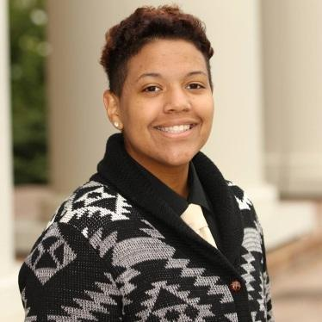
Tamara J. Morris-Thompson
5521 Skylar Creek LN, Buford, GA 30518 | (770) 776-9592 | tamara@morrthom.com

PROFESSIONAL EXPERIENCE
- Anyone can Whistle Technical Director/Team Leader Stagedoor Manor
- A Funny thing/Forum Technical Director/Team Leader Stagedoor Manor
- A Christmas Story & Carol Technical Director/ Team Leader Stagedoor Manor
- The Diary of Anne Frank Technical Director/ Team Leader Stagedoor Manor
- Mamma Mia Technical Director/ Team Leader Stagedoor Manor
- 42nd Street Technical Director/ Team Leader Stagedoor Manor
- Aida Technical Director/ Team Leader Stagedoor Manor
- The Addams Family Technical Director/ Team Leader Stagedoor Manor
- West Side Story Technical Director/ Team Leader Stagedoor Manor
- “Oliver” the Musical Technical Director/ Team Leader Stagedoor Manor
- Men on Boats Technical Director/ Team Leader Stagedoor Manor
- The Valley Where They Danced Assistant Set Designer/ ATD North Georgia Theatre
- A Funny thing/Forum Assistant Technical Director North Georgia Theatre
PROFESSIONAL/SUMMER YOUTH THEATRE EXPERIENCE
- The Gingerbread Man Set Crew/ Paint Crew North Georgia Theatre
- Rumpelstiltskin Set crew/Paint crew North Georgia Theatre
- Fabulous Fable Factory Set crew/Paint crew North Georgia Theatre
- Princess and the Pea Set crew/Paint Crew North Georgia Theatre
COLLEGE EXPERIENCE
- A Chorus Line Assistant Director/ Dance Captain Piedmont College
- Crimes of the Heart Assistant Technical Director Piedmont college
- When She Had Wings Assistant Technical Director Piedmont College

Education

B.A. Design Technical Theatre & Theatre Arts | May 2019 | Piedmont college
- Major: Design Technical Theatre & Theatre Arts
Related coursework: Advanced Technical Theatre, Audition Techniques, Advanced Special Techniques, Advanced Acting, Theatre History I & II, Script Analysis, Lighting Design, Set Design, Make-Up Design. Dance (Jazz, Tap, Ballet, and Modern), Stage Movement and Dance, Voice and Diction, Fundamentals of Directing, Introduction to Scenic Design, Fundamentals of Technical Theatre, Theatre Management, Stage Management.
- SPECIAL SKILLS
Proficient in use of basic power tools including table saw, router, jigsaw, panel saw and radial arm-saw. Scene Painting. Make-up training. Drawing, Valid GA driver’s license. CPR /First Aid certified. Certified Forklift truck driver. Basic rigging and bear loading. Proficient with Microsoft Office Suite of software. Organizational Skills.
- References:
Bill Gabelhausen (706)-338-0978
Henry Johnson (706)-424-2776
Cheryl Warnock (813)-610-5356 or tech@stagedoormanor.com
Production Manager, Stagedoor Manor
John Spiegel (336)-392-2044

* Please note Stagedoor Manor does 43 shows a summer*

